Before moving the cluster, check the cluster resource group status by using clRGinfo. It will show the which resource group is online on which node.
Go to the cluster resource group path: cd /usr/es/sbin/cluster/utilities/clRGinfo

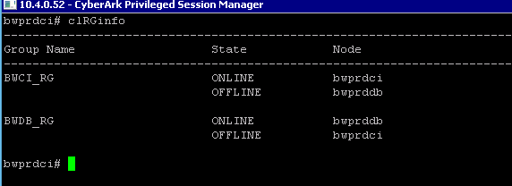

Go to “smit hacmp”

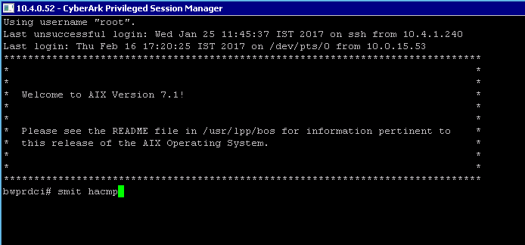

Select “System Management (C-SPOC)”
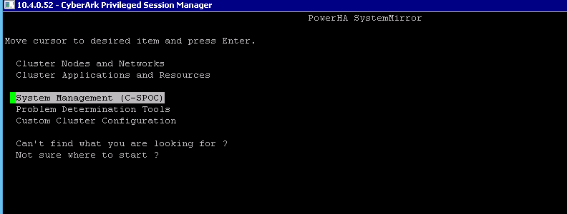

Select “Move Resource Groups to Another Node”
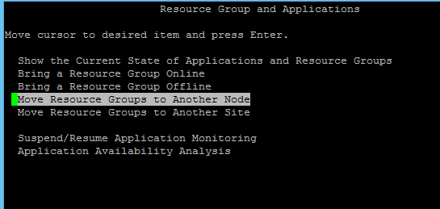

Select Resource Group of that particular server.
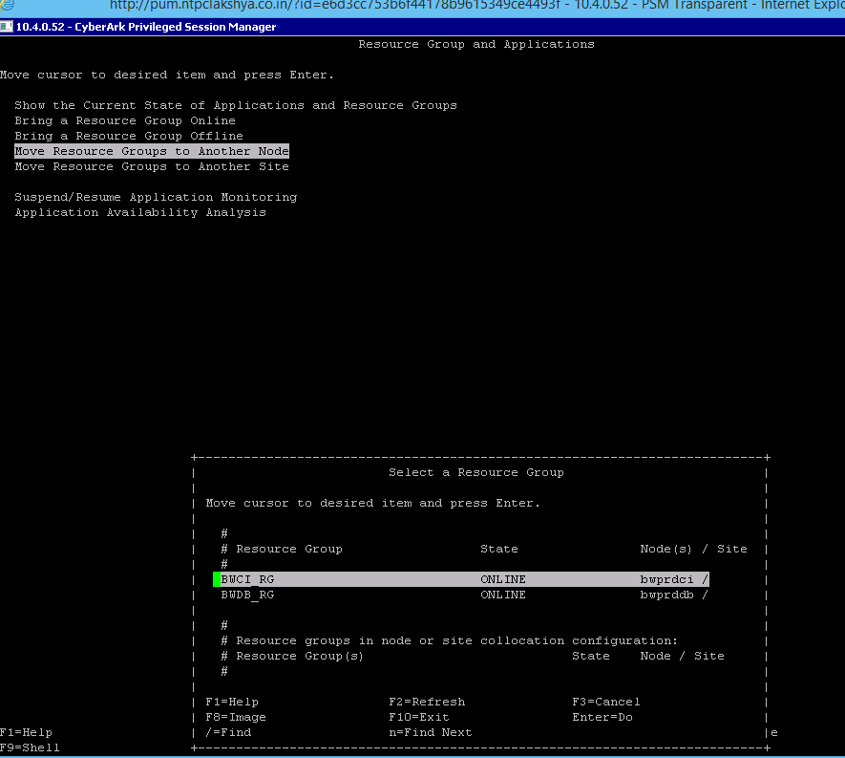

Select destination node
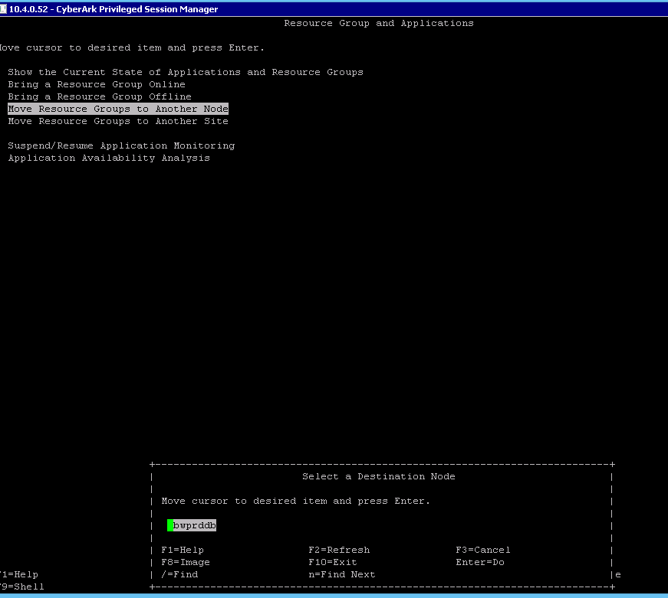

After selecting the resource group and destination node, next screen will show the entry fields of cluster which we selected
Below screen will show the moving cluster details, which we selected as resource group and destination node, then enter OK button.
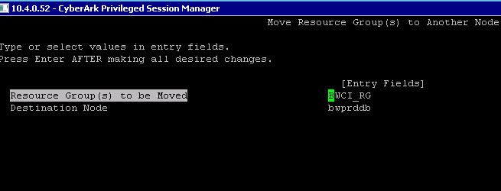
In this screen command status is showing OK, it means cluster moved to destination node successfully.
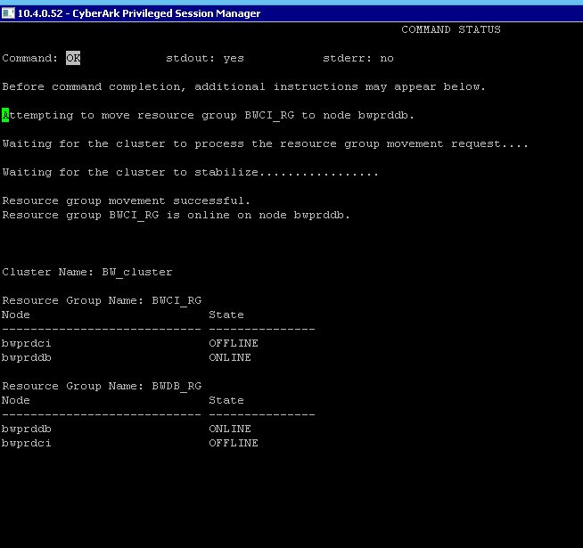

Below screen will show cluster status, whether the cluster was moved successfully or not.
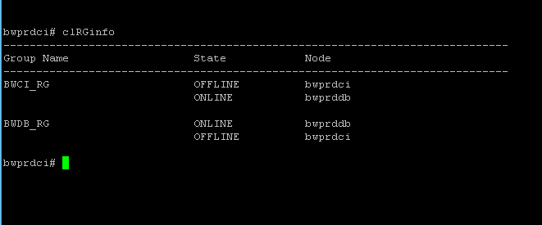
lssrc -ls clstrmgrES

